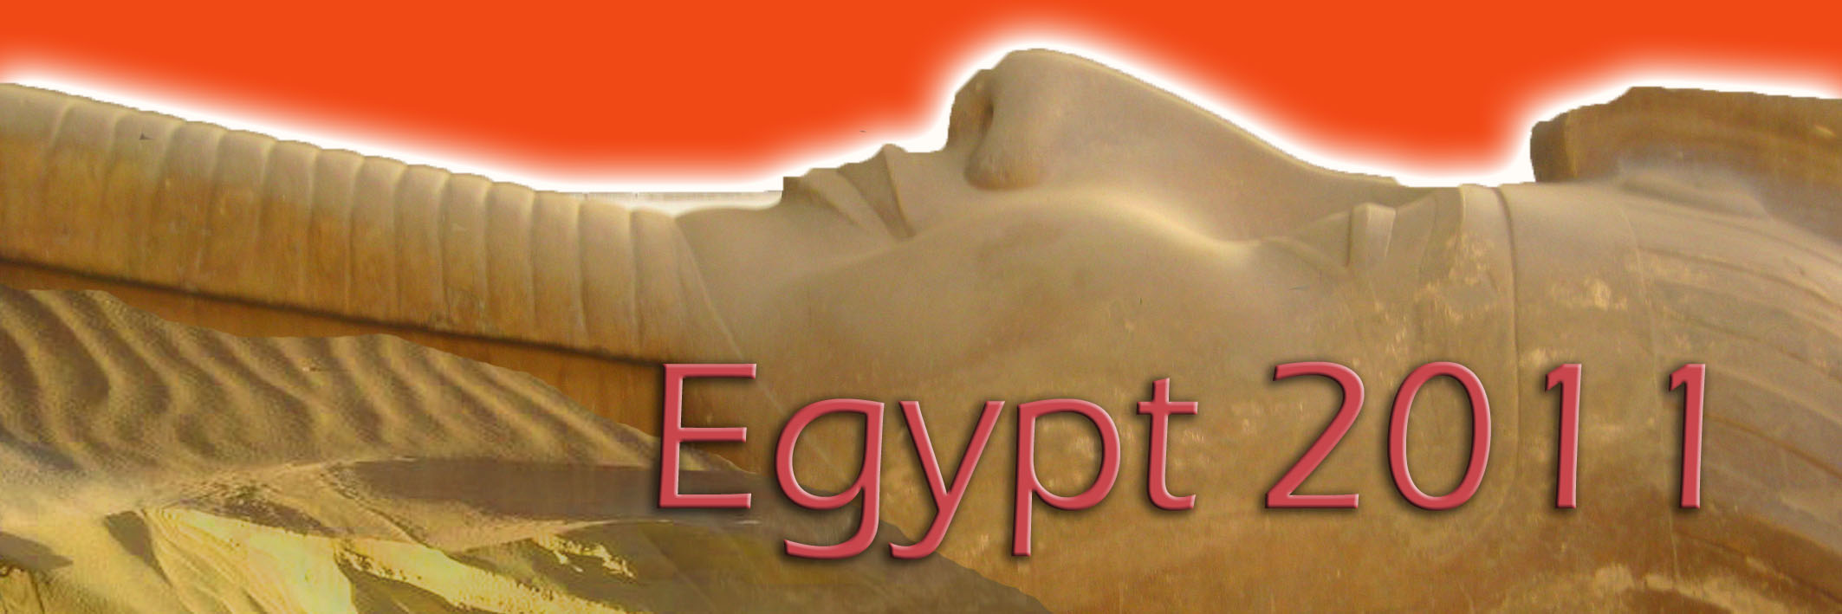

a joyful journey to the land of the pyramids
8 – 26 November 2011

For many of us we have completed a cycle or a circle and now we are standing on the outside looking at our completed task and thinking or feeling what now. Well the only now we can or must create is the now of joy. So do whatever gives you intense joy. The more joy you have the more joy you will attract. Create your own joy! Stop waiting for your neighbor to give it to you, stop waiting for the day when you will think you will wake up in the morning filled with joy.

Look at your life now and observe the reasons why you can create joy.

Berto and Tamar have teamed up with Joanna Castle. Joanna’s passion for travel has spanned over 35 years. Together we will share with you one of our favourite places in the world, ancient Egypt, a place that always fills us with great joy! As experienced Egyptian travellers, we will lead you to wander through street bazaars, brightly coloured scarves blowing in the breeze, piles of spices, the aroma of incense, turbanned men smoking shisha and drinking strong black tea all help to create the colourful ambience.

We will be exploring ancient and sacred temples throughout Egypt, sailing the Nile in luxurious cruisers as well as ancient fellucas. Experience the feeling of awe in this ancient land.

Itinerary

November 8 Depart Cape Town and arrive in Johannesburg for your flight to Luxor via Doha.

November 9 Arrive Luxor and travel to the West Bank and the village of Habu. Relax and unpack. Overnight Amenhotep Hotel.

November 10 We will visit the Colossus of Memnon, Ramses II funerary temple, Habu Temple, Ramses III funerary temple. Overnight Amenhotep Hotel.

November 11 Optional Hot Air Balloon ride at 5:30am (US$150). Back for breakfast. We will visit Queen Hatshepsut's Temple, Workman's village and tombs. 11/11/11 meditation. Overnight Amenhotep Hotel.

November 12 A visit to the Valley of the Kings, Tombs of the Nobels. Overnight
Amenhotep Hotel.

November 13 Free day in Luxor.
You can rent bicycles and explore the west bank villages, pre-dawn donkey ride up into the hills to visit tombs and valley of the Kings, (prices to be negotiated).There is also tea at the Winter Palace or a bit of shopping. Optional trip to Abydos and the Temple of Osirus
We move across the Nile and board our 5* Nile cruiser. Overnight Nile cruiser.

November 14 We will visit the Luxor Temple, Luxor French museum, Karnak Temple. Evening at Karnak Temple Sound and Light. Overnight Nile cruiser.

November 15 Sail the Nile, a visit to the Temples of Edfu and Komombo which has a nice bazaar. Overnight Nile cruiser.

November 16 Another day sailing the Nile. Overnight Nile cruiser.

November 17 Transfer to Aswan hotel check-in, rest, unpack. Free morning to explore the fantastic street bazaar. Afternoon we travel by motor boat to the Philae Temple, the Temple of Isis. Overnight Isis Island.

November 18 Early crossing the Nile by felucca. We then ride camels to a 5th century Coptic Monastery 30 minutes into the desert. Afternoon visit to the Nubian museum. Overnight Isis Island

November 19 Visit the local Nubian village by felucca, late afternoon sail on the Nile.
Overnight Isis Island.

November 20 Free morning. Aternoon drive to Abu Simbel. See the temples by moonlight. Overnight Eskaleh Nubian Hotel.

November 21 An early visit to the temple before the bus loads of tourists arrive. Early drive back to Aswan and our flight to Cairo.

For those who like to shop we will pay a visit to the Khan Kalili Bazaar, smoke shisha, drink tea or coffee and watch the world go by in the famous café Mahfouz sat and wrote in. Overnight Shepard Hotel.

November 22 To Saqqara, Pyramids, Sphnix, Solar boat. A visit to a Perfumerie. Overnight Shepard Hotel.

November 23 Geyer Anderson house, Coptic and Islamic Cairo. Overnight Shepard Hotel.

November 24 Egyptian museum. Overnight Shepard Hotel.

November 25 Free morning in Cairo. Pack luggage to leave for early afternoon check in for departure flight to Doha. Overnight Doha.

November 26 Departure to Cape Town.

Cost R23 900.00 per person sharing

Berto / Tamar 072 076 9720
info@solaraura.co.za
www.solaraura.co.za
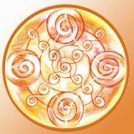

The small print (Terms and Conditions):

A deposit of R3 000.00 will secure you a place on the tour.

Included: All air, Land transport, Nile Cruise (with 3 meals per day), hotels with breakfasts, sailing, camel rides, tours, entrances, Egyptologist. 16 nights in Egypt.

Not included: beverages, lunch and dinner (excluding days on Nil cruise), items of a personal nature, visas.

Visas will be obtained in South Africa prior to departure. Please ensure that your passport is valid for 6 months from arrival date in Egypt. Visas are free to South Africa citizens, courier fee applies. Single supplement applies.

NB: This itinerary is not written in stone and subject to change.

